Viruses and plant species identity alters behavior of predators and prey in an aphid-legume system

Abstract

Herbivorous insects have dramatic impacts in crop systems as vectors of plant pathogens. Recent work has demonstrated that predator behavior and herbivore response to predators can be altered by host-plant traits. Typically, this is considered as interspecific variation, or species identity effects. We consider here an additional level of host-plant variation status of plants. In an experiment that manipulated both plant species composition and virus present, we ran a closely-monitored greenhouse experiment. We recorded minute-by-minute observations of predatory ladybird beetle and aphid behavior and compared differences between uninfected and infected plant-herbivore systems among four legume species (pea, vetch, lentil, and fava). We found that foraging effort was altered by host plant identity, with strongest effects seen on a cover crop compared to two food crops. Virus reduced number of predation events observed. Aphid fleeing response frequency was interactively determined by virus and plant species identity. In some plant species virus had a dramatic impact on dispersal, while in another species virus did not change dispersal at all (lentil). Through these behavioral experiments, we show infection status adds another level of variation in host plant traits that impacts plant herbivore interactions alongside interspecific interactions. We suggest that host-plant variation in infection status is an important consideration in understanding variation in the top-down strength of predators in insect communities.

Introduction

*Big picture that needs to be set up in introduction*: aphid-vectored viruses change aphid behavior, leading to different patterns of host-plant use and change in predation risk

*Basic information:* Pea aphids are an economically important damaging pest of legume crops worldwide (citations). While feeding on plant phloem, aphids can transmit carried pathogens to plants (citations). One of the costliest impacts is transmission of pathogens, which can far outweigh the damage caused by herbivory itself (citations). Viruses can also alter plant defensive chemistry and nutritional quality, leading to indirect benefits to the vector, further exacerbating the intensity of aphid outbreaks (citations). Viruses are also increasingly appreciated for their ability to alter aphid behavior in addition to plant response to herbivores, the ecological consequences of these behavioral changes are still poorly understood.

Methods

*Study system details*

This experiment used Pea aphids collected from Palouse agroecosystems (Eastern WA and Idaho, USA). Aphids were reared in greenhouse conditions on broad bean (*Vicia faba*), a universal host of Pea aphid populations.

The virus of interest is the RNA virus PEMV (pea enation mosaic virus) which infects cultivated legumes, including lentil, vetch, clover and dry pea (citations).

We used the convergent ladybeetle as our focal predator species. (Citations on its importance as a natural enemy and biological control agent in the field)

*Timing of plantings*

We ran two trials of the experiment. In trial 1, Seeds were sown into X size pots on Y dates. In trial 2, seeds were sown into the same pots on Y dates. We planted pea, fava, lentil, and vetch.

*Setup of experiment*

We ran a 2x3 factorial experiment, with PEMV presence absence and three plant species

The five plant species were arranged in a cross pattern (See Figure S1)

Plants were infected before the experiment (only fava)

Fava was added to arena with pea, lentil, vetch and clover already arranged in a glass terrarium

Glass terrarium already had warmed up ladybird beetles waiting to eat.

*Statistical analyses*

Results

Discussion

References

Figures

Figure 1. Ladybird beetles spent significantly more time foraging on vetch compared to Pea and Lentil.

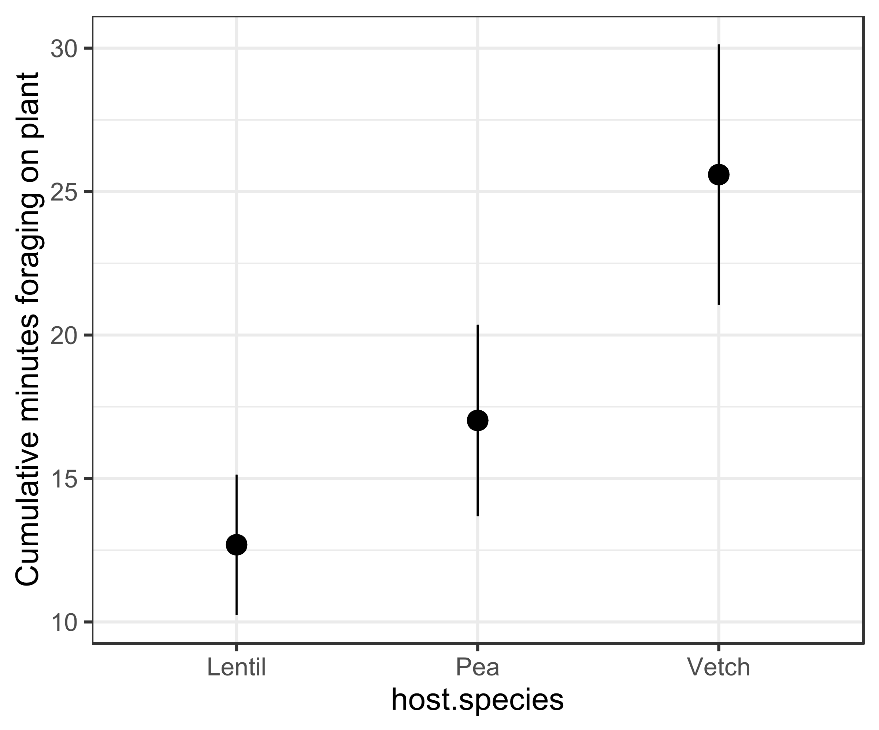

Fig 3. Aphids on infected plants experience fewer attacks from ladybird beetles.

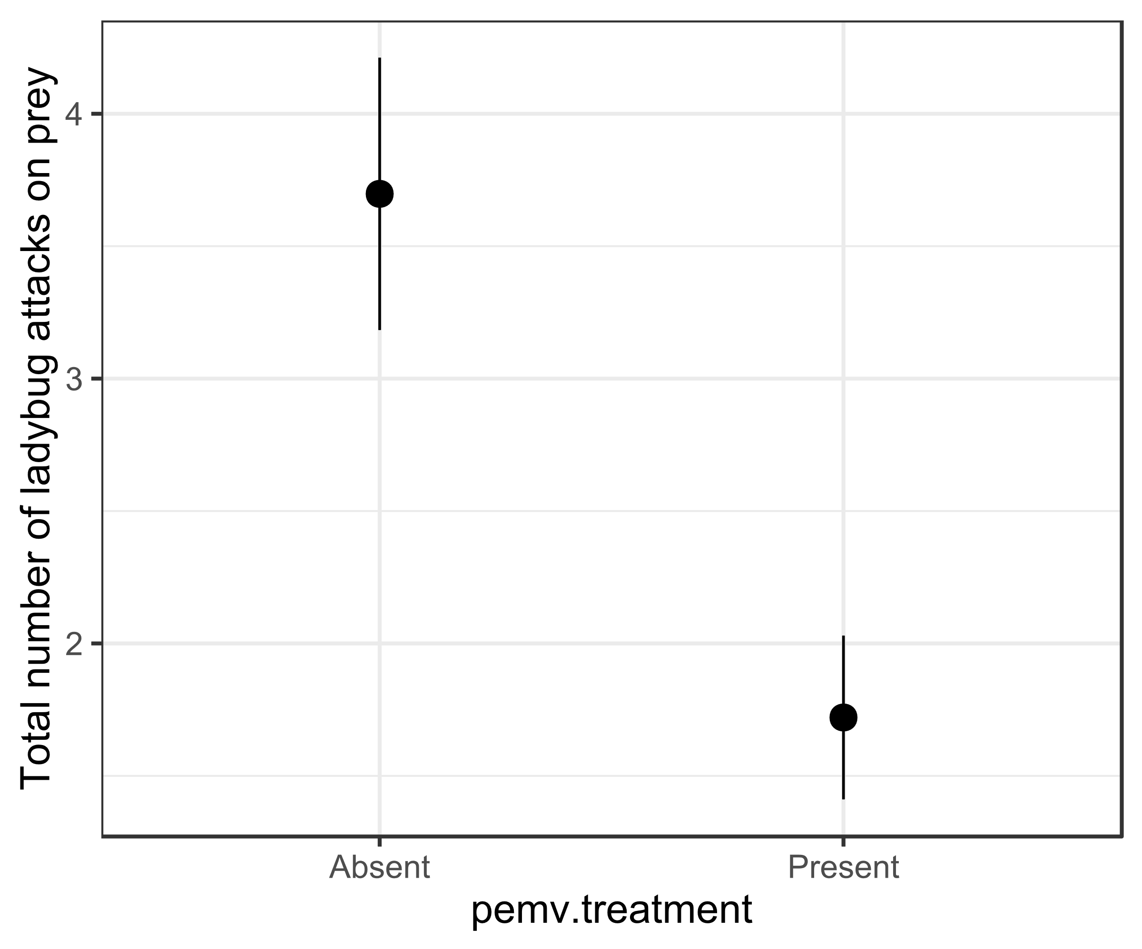

Fig 3. Aphid dispersal events were highest on vetch, but this effect was attenuated by viral presence, reducing likelihood of dispersal in response to predation to be equal to that of the lowest rate plant (Lentil). This is likely driven by the lower rate of predatory attacks in infective systems (fig 3), while increased dispersal events driven by plant traits which also mediated predator strength.

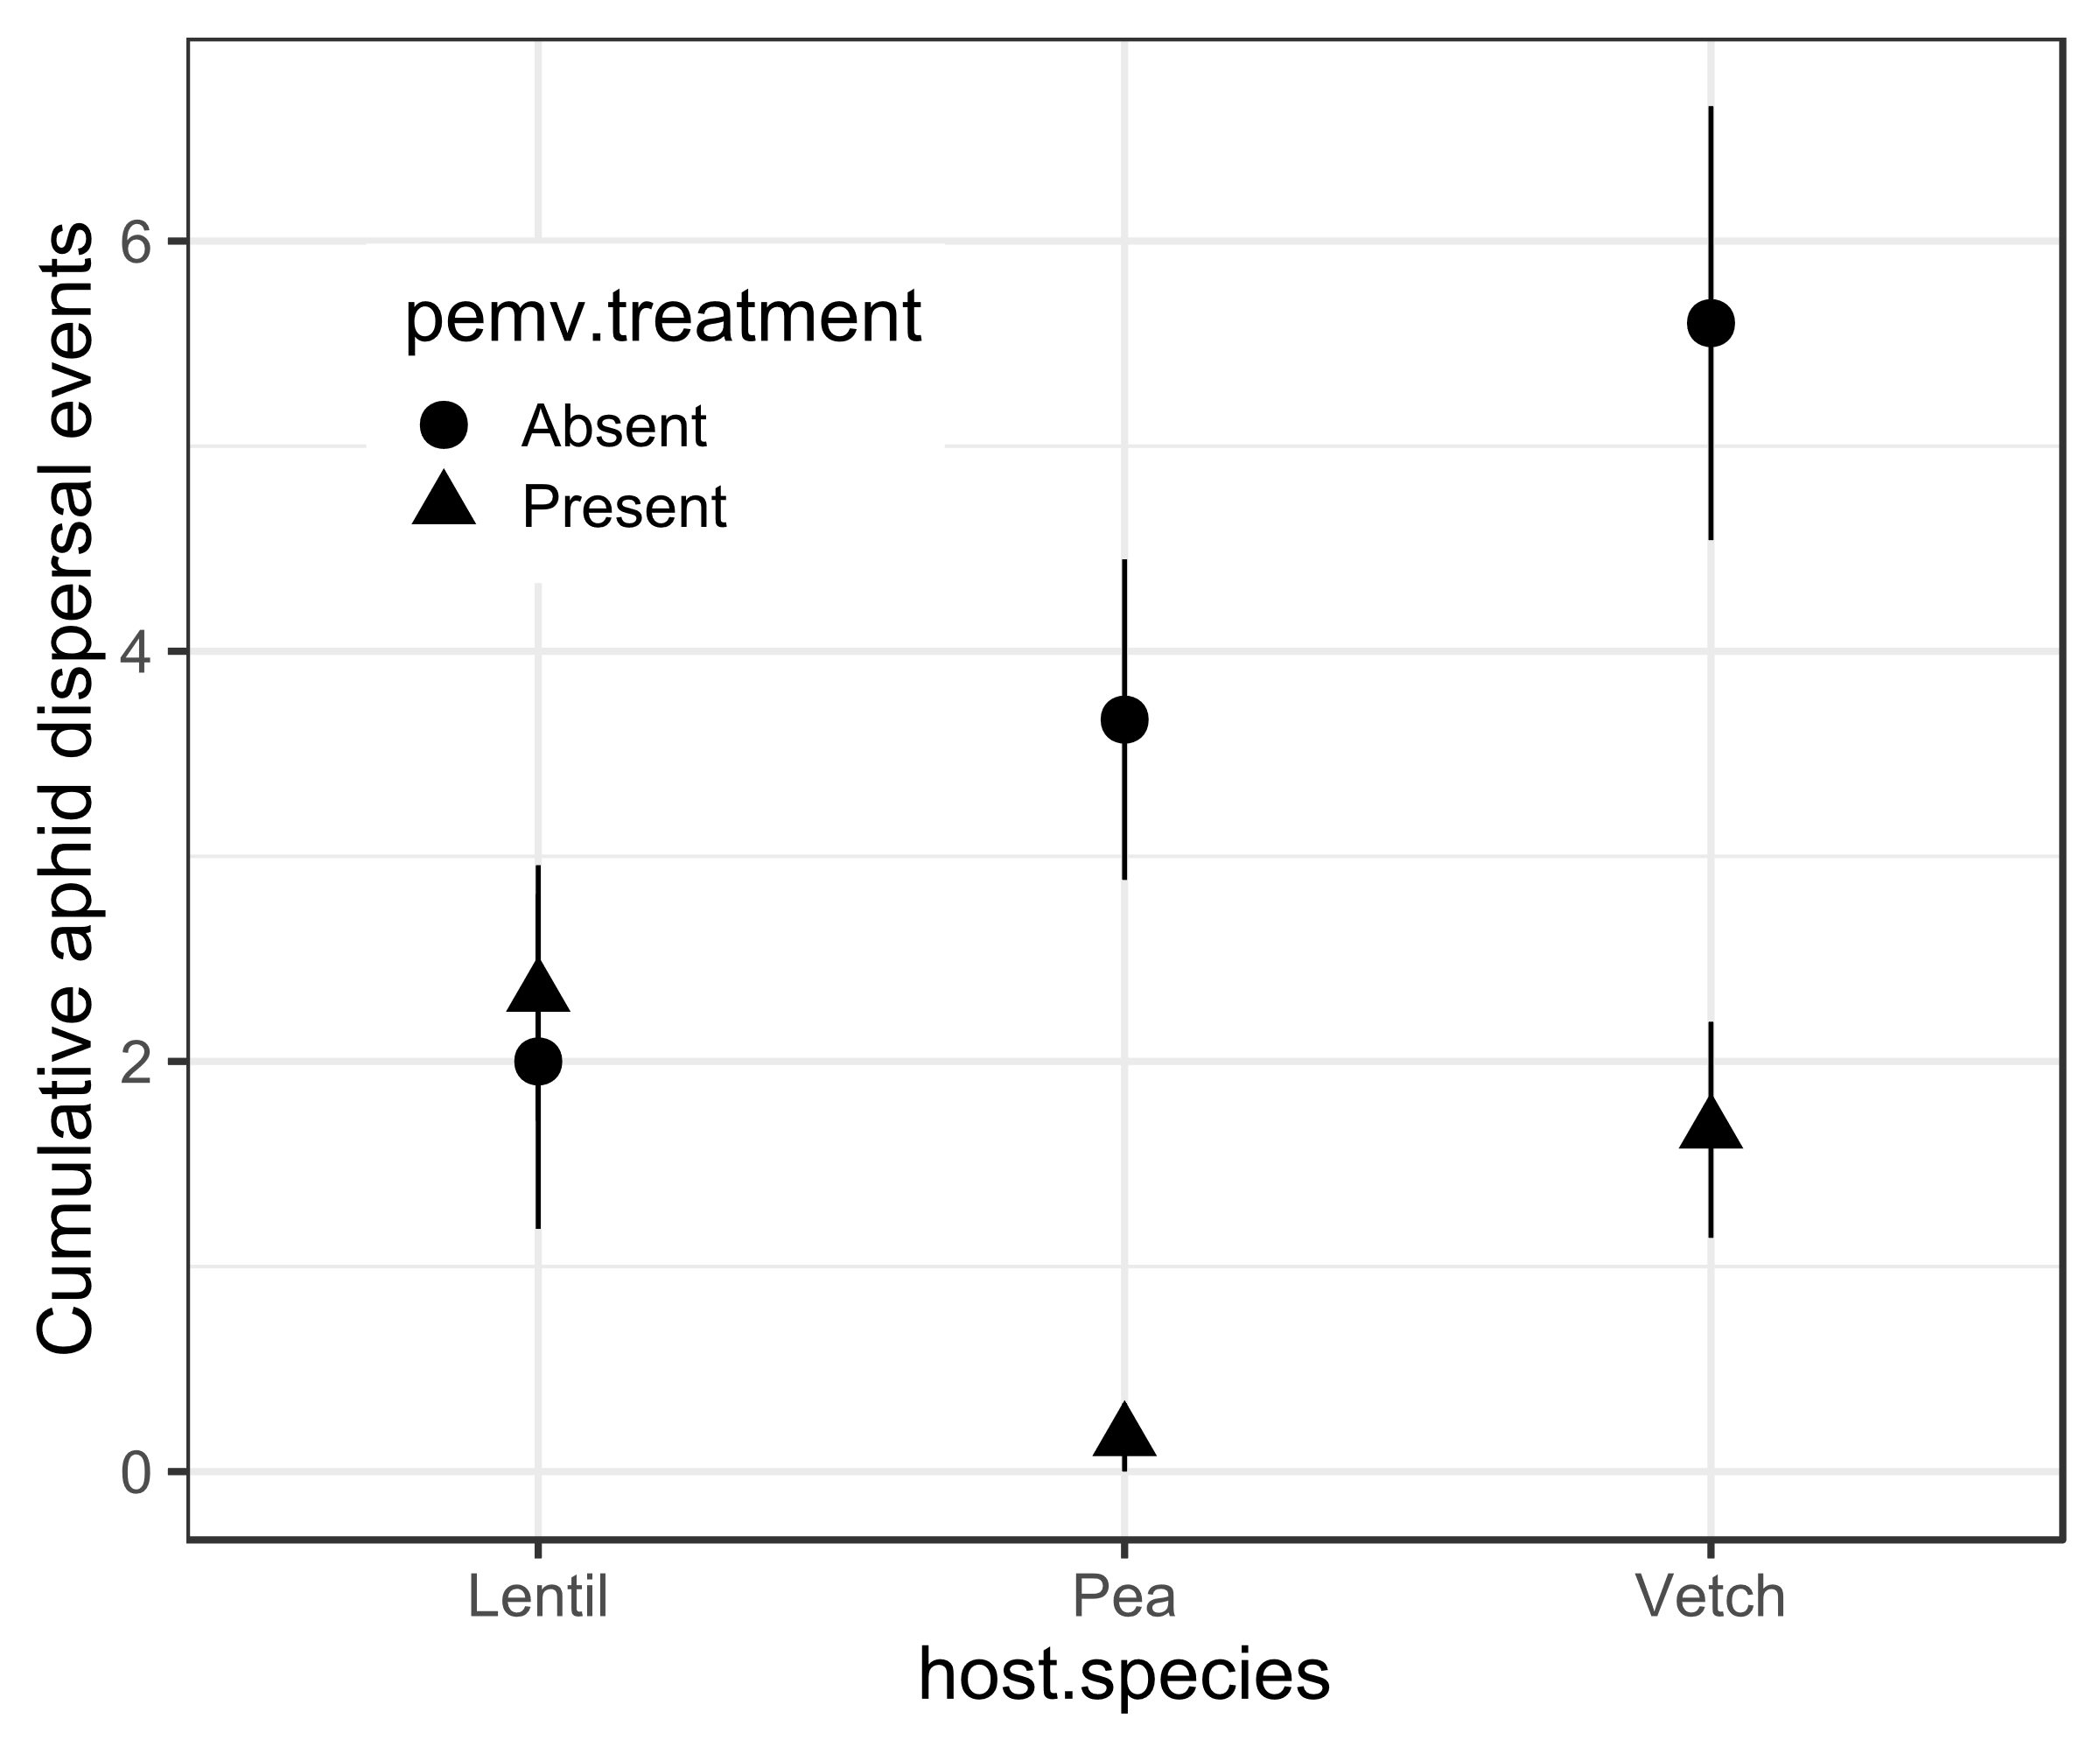

Tables.

Add sequential tables following order of figures for GLMM (all Poisson fit)